**Online Shopping System**

**Software Requirements Specifications**

**1.Introduction:**

**1.1 Purpose:**

This document is meant to delineate the features of Online Shopping System (OSS), so as to serve as a guide to the developers on one hand and a software validation document for the prospective client on the other. The Online Shopping System (OSS)for general shopping web application is intended to provide complete solutions for vendors as well as customers through a single get way using the internet

It will enable customer to browse through the shop and purchase them online without having to visit the shop physically. It helps users to know about the product using a discussion forum. It enables admin to analyse the sales to know which products are giving profits and which are giving loses. The administration module will enable a system administrator to add or remove products and maintain various lists of shop category.

**1.2 Scope:**

This system allows the customers to maintain their cart for add or remove the product over the internet. It helps users to know about the product using a discussion forum. It enables admin to analyse the sales to know which products are giving profits and which are giving loses.

**1.3 Definitions, Acronyms:**

          OSS- Online Shopping System

                   SRS- Software Requirement Specification

                   GUI- Graphical User Interface

XAMPP- X (any OS) Apache Mysql Php PERL.

                   Stakeholder- The person who will participate in system

                   Ex. Customer, Administrator, Visitor etc.

**1.4. Overview:**

The system helps in buying of goods, products and services online by choosing the listed products from website (E-Commerce site).The system work on internet server, so it will be operated by any end user for the buying purpose.

**1.5. Problems in existing system:**

1. Time consuming.

2. Expensive.

3. Needed an agent.

4. We have to out for that.

**2.General Description**

2.1. Product Perspective:

The proposed system is a solution carry out buying products online.

2.2. Product Functions:

The system allows the user to buy/sell products online across internet connection globally.

2.3. User Characteristics:

There are 2 kinds of users for the proposed system.

* **Administrators**:

Administrators are the ones who adds or administers the categories for the products, and can add or remove the products. Responds to customer feedback given in the discussion forum.

* **End Users/Customers**:

The end user will be the one who visits the website and buys products online from the ones added by the Administrators. They can add their respective feedbacks in Discussion forum.

2.4. General Constraints:

* A local XAMPP server is used for hosting the website.
* A Database containing product and user details is maintained.
* It takes three months of effort in developing the system.
* The developed system should run under any platform (Unix, Linux, Mac, Windows etc.) that contains a web browser which supports PHP, JavaScript, HTML, CSS, Bootstrap, and AJAX.

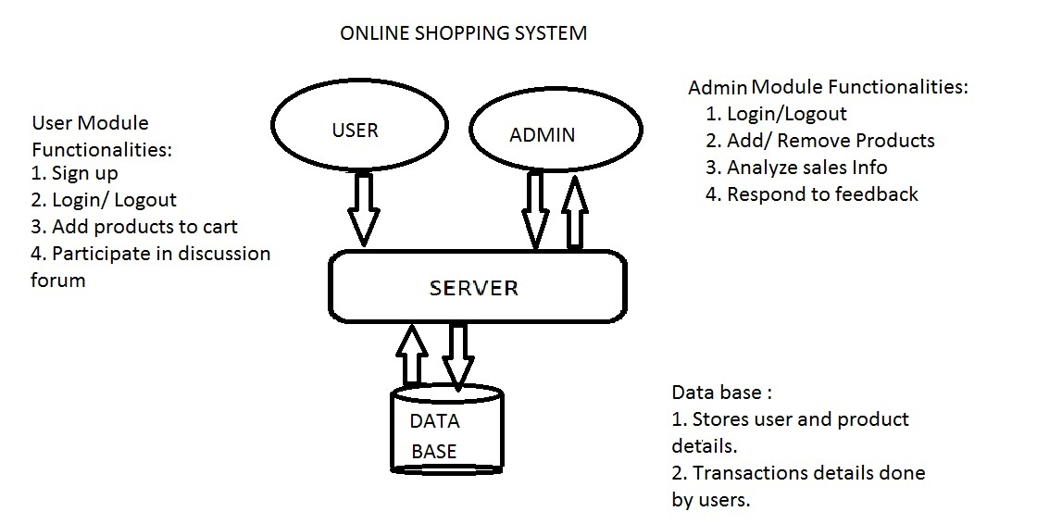

**3. Functional Requirement**

This section provides requirement overview of the system. Various functional modules that can be implemented by the system will be –

3.1 Functions:

**User:**

3.1.1 Registration

If customer wants to buy the product then he/she must be registered, unregistered user can’t go to the shopping cart.

3.1.2 Login

Customer logins to the system by entering valid user id and password for the shopping.

3.1.3 Changes to Cart

Changes to cart means the customer after login or registration can make order or cancel order of the product from the shopping cart.

3.1.4 Logout

          After the order or surf the product the customer can logout.

3.1.5 Report Generation

After all transaction, the system can generate a report of the transaction made by the user.

**Admin:**

1. Login

Customer logins to the system by entering valid user id and password for the shopping.

2.Changes to Product Database

Changes to product database means the admin after login can add or remove the products from the database.

3.Logout

   After the order or surf the product the customer can logout.

4.Analytical OUTPUT

Admin can have the mined data about all the sales such as diagrammatic representations of sale details.

3.2 Technical Issues:

This system will work on client-server architecture. It will require a local server and which will be able to run PHP application. The system should support some commonly used browser such as IE, Chrome, Firefox, Opera, Tor etc.

Each part of the user interface intends to be as user friendly as possible. The fonts and buttons used will be intended to be very fast and easy to load on web pages. The pages will be kept light in space so that it won’t take a long time for the page to load.

**4.1.2.   Hardware Interfaces**:

* Processor: Pentium or Higher.
* RAM: 512MB or Higher.

**4.1.3.   Software Interfaces**:

* Operating System:  Unix, Linux, Mac, Windows etc.
* Development tool: PHP: Hypertext Pre-processor, HTML, CSS, Bootstrap, JavaScript.
* Data Base: MySQL connected with local server (XAMPP).
* Apache Server (XAMPP)

Various interfaces for the product could be-

a. Login Page

b. Registration Form

c. There will be a screen displaying information about product that the shop having.

d. If the customers select the buy button then another screen of shopping cart will be opened.

e. After all transaction the system makes the selling report.

**5. Performance Requirement**

There is no performance requirement in this system because the server    request and response is depended on the end user internet connection and server specifications.

**6. Design Constraints**

The system shall be built using a standard web page development tool that conforms to Microsoft’s GUI standards like HTML, XML etc.

**7. Other requirements**

a. This system can be extended to have a money transaction system by including banking options.

b. Product news based on the interests of users by providing links.

c. Providing Ajax technology to refresh our website dynamically.

By

Y. Sai Harsha (411581),

A. Sasank (411564),

V.R.N. Sri Charan Priyatham (411573).